Instructions:
You may change the copy in this package to best fit your needs and marketing stylesheet. This package includes:
- Brandable eBook PPT
- Email with images
- Email without images
- Landing page Content
- Images

Custom Branding the eBook
- Open the PowerPoint Presentation containing the eBook: Reinvent business productivity with Microsoft Dynamics 365 and Microsoft Office 365.
- On the last slide (slide 8) remove the contact information in red and replace it with your company’s contact info.
- If you have a logo you would like to you use, you can do so by using the “Insert Image” feature.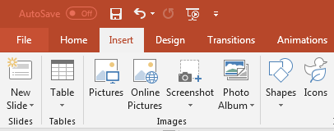

- Once you are finished customizing the PowerPoint Presentation, select File>>Save As and change the file format from PPT to PDF.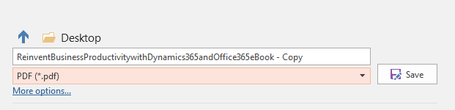

Leveraging Email Content
You may edit the provided email content to best fit your needs. We have provided an email design with images already inserted as well as a version with no images.
- Copy and paste this content into Outlook or other email distribution tool.
- Email copy includes text in red that should be changed to include your company’s name.
- Attach the PDF version of the eBook or…
  - Link to a landing page for the custom branded eBook
  - To create a landing page, follow the instructions in the next step below.
  - Once you have a URL for the landing page you can create a hyperlink by highlighting the text: “Download eBook »” and follow these steps at this link.
- You are ready to send the email!
*Remember to remove all copy in red and replace it with appropriate info.

Landing Page
If you are able to easily create a new landing page and upload a file to your website, ClickDimensions domain, or other service, you can use the landing page content and images included in this packet to best meet your needs. Follow the instructions in the step above to create an email that links to your eBook landing page.
*A sample layout for the landing page is included in the copy packet

Images
This package includes logos, banner and other images that can be used in emails, blog posts and landing pages as needed to promote the eBook.

