Email with Link to Landing Page

SUBJECT: Win with customers by reinventing productivity

Hi CONTACT,

Are disconnected systems holding your businesses back? In a world of rapid change, businesses need to make every minute count and every customer engagement shine to stand out from the competition.

Please enjoy our complimentary eBook, Reinvent business productivity with Microsoft Dynamics 365 and Microsoft Office 365

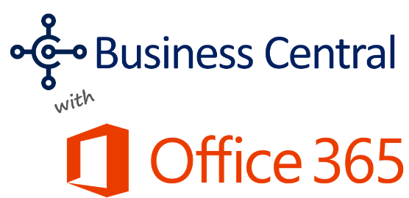
Imagine what you could do when you upgrade to a cloud-based, all-in-one business management solution…
- Connect people, processes, and systems
- Work from anywhere, wherever business takes you
- Improve customer interactions
- Simplify reporting and making better decisions

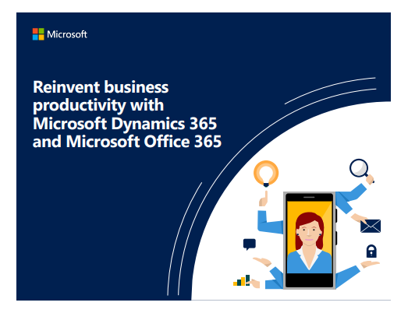
COMPANY NAME is now delivering Microsoft Dynamics 365 Business Central, a comprehensive management system that helps businesses manage financials, sales, service and operations easier and faster from day one.

Please enjoy our complimentary eBook, Reinvent business productivity with Microsoft Dynamics 365 and Microsoft Office 365

<link to landing page or attach> Download eBook »

Sincerely,
SIGNATURE

###

Email with File Attached

SUBJECT: Win with customers by reinventing productivity

Hi CONTACT,

Are disconnected systems holding your businesses back? In a world of rapid change, businesses need to make every minute count and every customer engagement shine to stand out from the competition.

Please enjoy our complimentary eBook, Reinvent business productivity with Microsoft Dynamics 365 and Microsoft Office 365

Imagine what you could do when you upgrade to a cloud-based, all-in-one business management solution…
- Connect people, processes, and systems
- Work from anywhere, wherever business takes you
- Improve customer interactions
- Simplify reporting and making better decisions

COMPANY NAME is now delivering Microsoft Dynamics 365 Business Central, a comprehensive management system that helps businesses manage financials, sales, service and operations easier and faster from day one.

Sincerely,
SIGNATURE
###

Landing Paged
Title H1: Better Together: Microsoft Dynamics 365 Business Central and Office 365
Imagine what you could do when you upgrade to a cloud-based, all-in-one business management solution…
- Connect people, processes, and systems
- Work from anywhere, wherever business takes you
- Improve customer interactions
- Simplify reporting and making better decisions
Microsoft Dynamics Business Central is a comprehensive management system that helps you manage financials, sales, service and operations easier and faster from day one.
Want to reinvent the way you do business? Start by downloading this free eBook
This e-book explores how the Dynamics 365 Business Central integrates with Office 365 to connect business processes and personal productivity like never before, bringing insight and efficiency to your daily tasks.
###
Layout suggestion:
