Email 1 – Video 1

SUBJECT: Move to modern: Free Video Demo of Dynamics 365 Business Central

Hi CONTACT,

Are you ready to upgrade to a modern, cloud based business management solution?

COMPANY NAME is now delivering Microsoft Dynamics 365 Business Central, an all-in-one comprehensive management system that helps businesses manage financials, sales, service and operations easier and faster.

Checkout what Business Central can do for you today. Watch a guided tour in this video Demo:

<link to landing page or YouTube URL> Watch Demo »

Sincerely,
SIGNATURE

###

Email 2 – Video 2

SUBJECT: Get Started: Free Video Demo of Dynamics 365 Business Central

Hi CONTACT,

Have you thought about upgrading to a new business management solution but worry about the strain it may cause to your business? With Microsoft Dynamics 365 Business Central it’s easier than you think to get started.

COMPANY NAME is now delivering Microsoft Dynamics 365 Business Central, an all-in-one comprehensive management system that helps businesses manage financials, sales, service and operations easier and faster.

Checkout how simple it is to get started with Business Central. Watch this video demo to see for yourself:

<link to landing page or YouTube URL> Watch Demo »

Sincerely,
SIGNATURE

###
Landing Paged 1 – Video 1
Title H1: Introduction to Microsoft Dynamics 365 Business Central
Reimagine the way you do business with a comprehensive cloud-based management solution. Microsoft Dynamics Business Central is an all-in-one business software suite that helps you manage financials, sales, service and operations easier and faster from day one.
Want to reimagine the way you do business? Start by watching this video introduction to Microsoft Dynamics 365.
COMPANY NAME is your provider for Microsoft Dynamics 365 Business Central, a robust business management system that helps you manage financials, sales, service and operations easier and faster.

###
Layout suggestion:
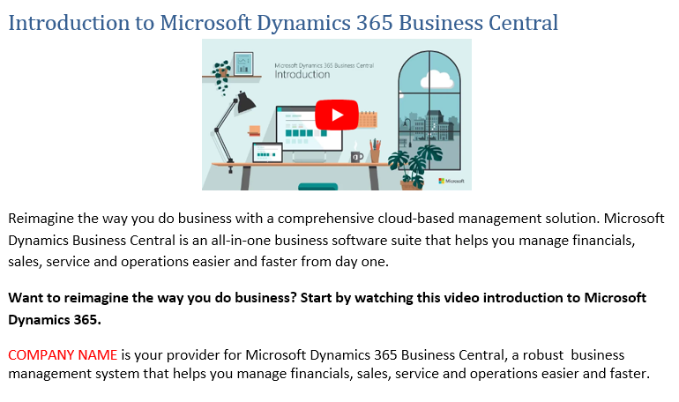

Landing Paged 2 – Video 2
Title H1: Get started with Microsoft Dynamics 365 Business Central
Microsoft Dynamics 365 Business Central makes upgrading to a modern, cloud based business management solution simpler.

See how you can get started today. Watch this video demo to see for yourself how it simple it is to get started Business Central

COMPANY NAME is your provider for Microsoft Dynamics 365 Business Central, a robust business management system that helps you manage financials, sales, service and operations easier and faster.

###
Layout suggestion: